Beginning

Visual Basic® Express

A Computer Programming Tutorial

12th Edition

Philip Conrod & Lou Tylee
©KidwareSoftware LLC

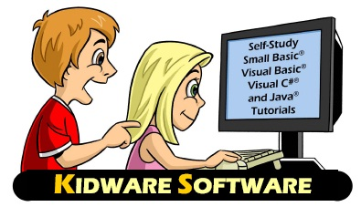

KIDWARE SOFTWARE
PO Box 701
Maple Valley, WA 98038
http://www.kidwaresoftware.com
http://www.computerscienceforkids.com

Copyright © 2013 by Kidware Software LLC. All rights reserved

Published by:
Kidware Software, LLC
PO Box 701
Maple Valley, Washington 98038
1.425.413.1185
www.kidwaresoftware.com
www.computerscienceforkids.com

All Rights Reserved. No part of the contents of this book may be reproduced or transmitted in any form or by any means without the written permission of the publisher.

Printed in the United States of America

ISBN-13: 978-1-937161-47-7

Previous edition published as “Beginning Visual Basic Express: For High School Students – 2010 Edition”

Book Cover Illustration by Kevin Brockschmidt
Copy Editors: Stephanie Conrod & Jessica Conrod

This copy of the Beginning Visual Basic Express Tutorial and the associated software is licensed to a single user. Copies of the course are not to be distributed or provided to any other user. Multiple copy licenses are available for educational institutions. Please contact Kidware Software for school site license information.

This guide was developed for the course, “Beginning Visual Basic Express” produced by Kidware Software LLC, Maple Valley, Washington. It is not intended to be a complete reference to the Visual Basic language. Please consult the Microsoft website for detailed reference information.

This guide refers to several software and hardware products by their trade names. These references are for informational purposes only and all trademarks are the property of their respective companies and owners.

Microsoft, Visual Studio, Small Basic, Visual Basic, Visual J#, and Visual C#, IntelliSense, Word, Excel, MSDN, and Windows are all trademark products of the Microsoft Corporation. Java is a trademark product of the Oracle Corporation. JCreator is a trademark product of XINOX Software

The example companies, organizations, products, domain names, e-mail addresses, logos, people, places, and events depicted are fictitious. No association with any real company, organization, product, domain name, e-mail address, logo, person, place, or event is intended or should be inferred.

This book expresses the author’s views and opinions. The information in this book is distributed on an "as is" basis, without and expresses, statutory, or implied warranties.

Neither the author(s) nor Kidware Software, LLC shall have any liability to any person or entity with respect to any loss nor damage caused or alleged to be caused directly or indirectly by the information contained in this book.

